**VIRTUALIZATION AND CONTAINERIZATION:**

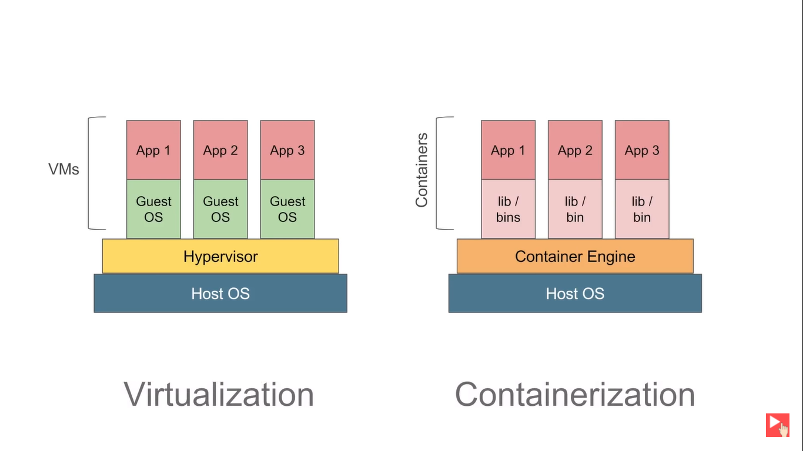

**WHY DOCKER:**

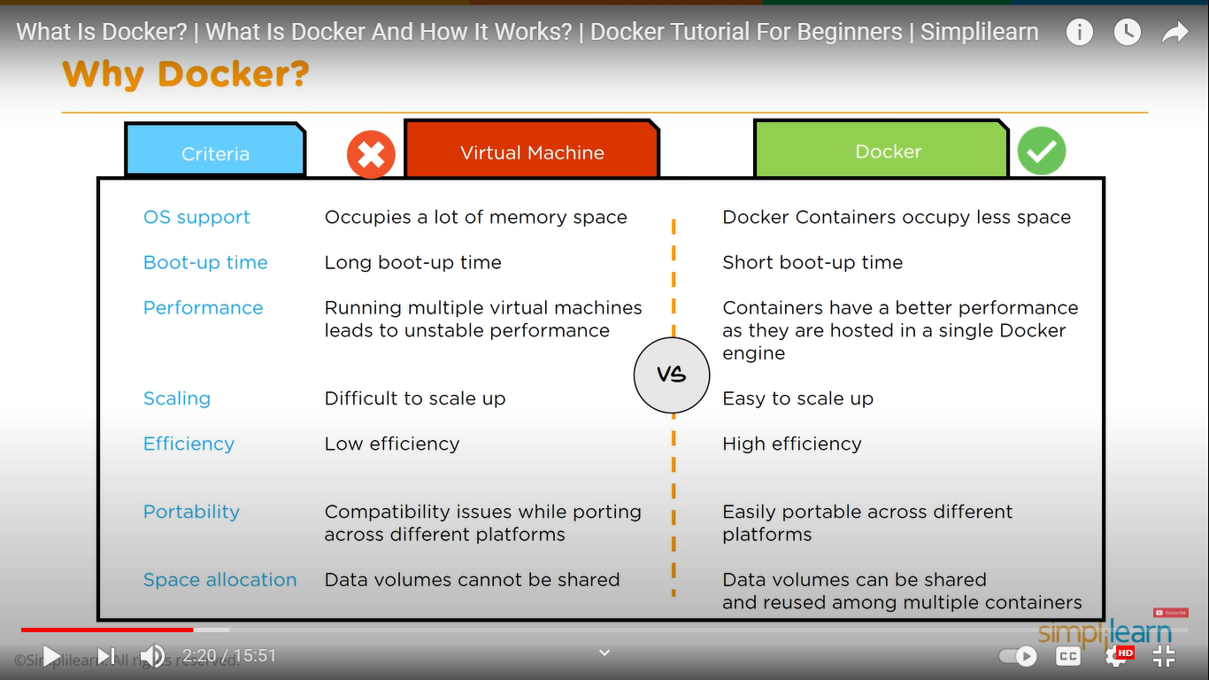

**DIFFERENCE BETWEEN DOCKER IMAGE AND DOCKER CONTAINER:**

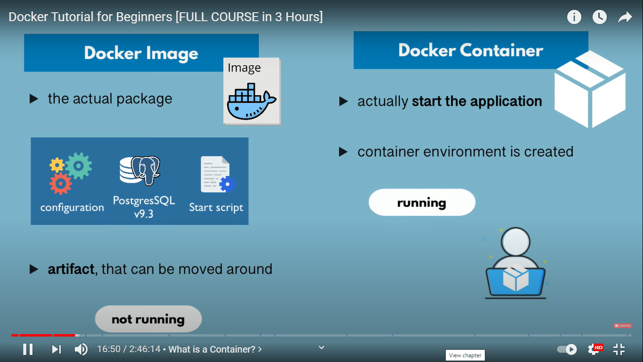

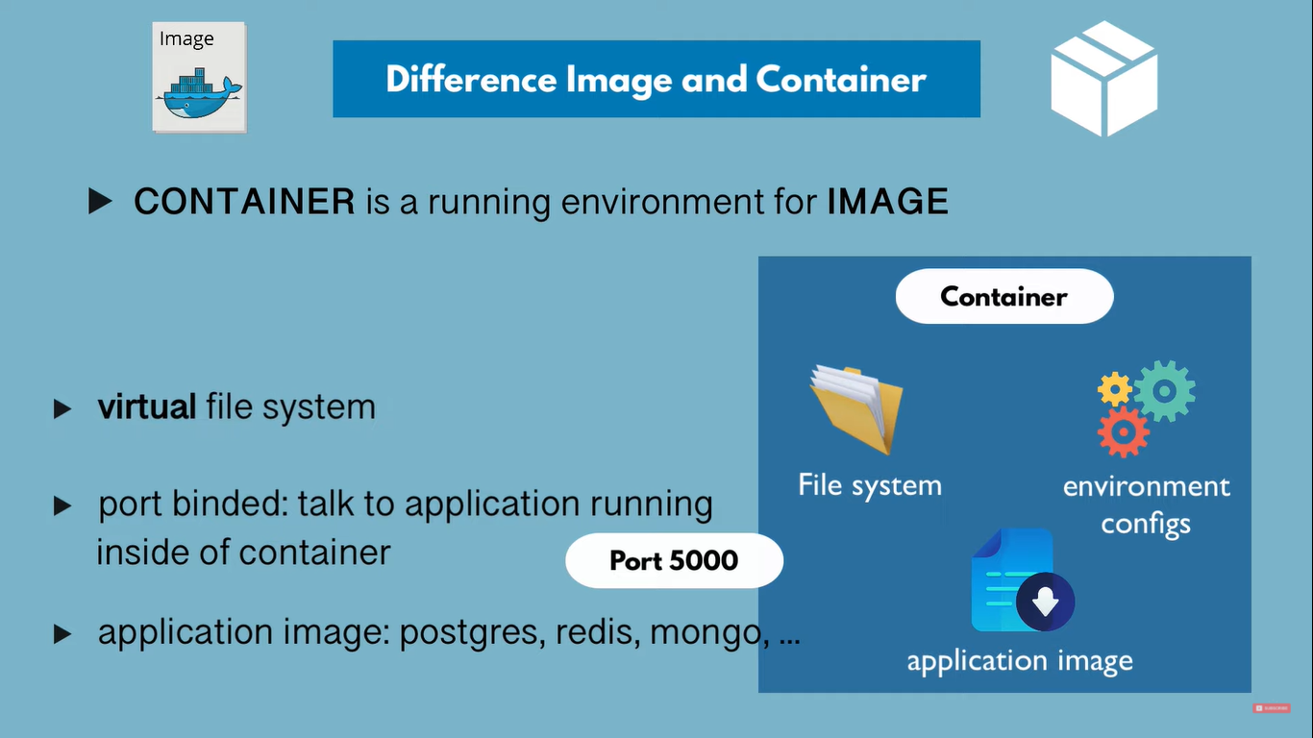

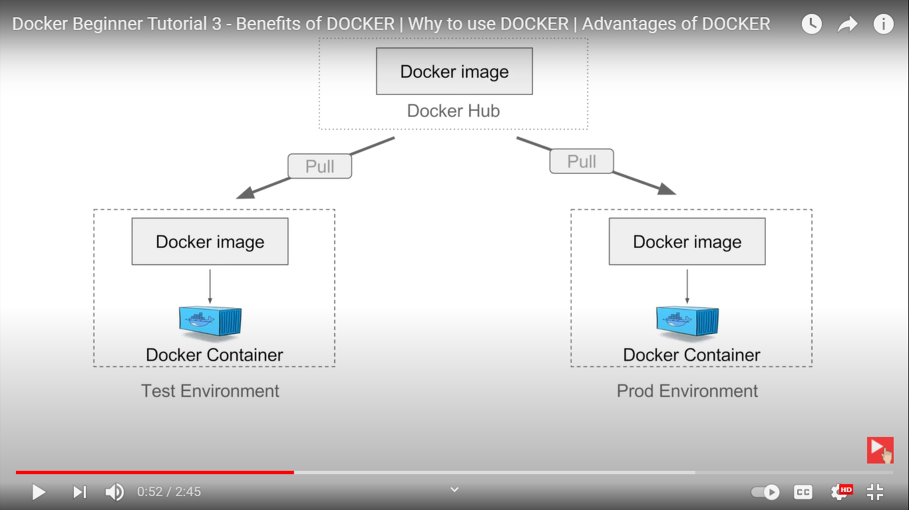

**BASIC COMMANDS:**

1. **docker version à** displays version of client and server
2. **docker info** à detailed information
3. **docker <command-name> --help** à detailed information of a command
4. **docker login** à login to your account

**DOCKER IMAGES: ( DANGLING – IS THE IMAGE ASSOCIATED WITH AN RUNNING CONTAINER)**

1. **docker pull <image_name> à** Used to pull images from repository
2. **docker images à** To view the list of images
3. **docker rmi <image-id> à** removes the images
4. **docker inspect <image-id> à** details of the image (also layers)

**DOCKER CONTAINERS:**

1. **docker run <image-name>**  à Starts new container with a command
2. **docker run -d <image-name> à** Runs in detached mode
3. **docker run <image-name>:<version> à** pulls image and starts the container
4. **docker run -d -p6000<host-port>:<container-port> <image-name> à** binds the host and container port
5. docker run **--name <new-name>** <image-name>:<version> à changes the container name
6. **docker run -it <image-name> à** runs the container in an interactive mode
7. **docker ps** à List the number of containers
8. **docker ps -a à** lists all the containers
9. **docker stop <container-id> à** Stops the container
10. **docker start <container-id>** à Starts the stopped container
11. **docker attach <container-id> à** attaches the started container
12. **docker kill <container-id> à** exits from the running container
13. **docker rm <container-id> à** removes the container
14. Docker –name

**DEBUGGING:**

1. **docker logs <container-name> à** shows logs of container
2. **docker history <image-name> à** shows history of the image
3. **docker exec -it <container-id> /bin/bash** à Interactive terminal(-it) used for debugging

**SYSTEM:**

1. docker stats à displays memory usage
2. docker system df à displays disk usage
3. docker system prune à read about it in –help (be careful while using this)

**DIFFERENCE BETWEEN DOCKER RUN AND START:**

**docker run** is used to create a new container with specified attributes, and suppose we stopped the container and we need to work on that container again then we will not create it again instead we **docker start** the existing container.

**CONTAINER PORT VS HOST PORT:**

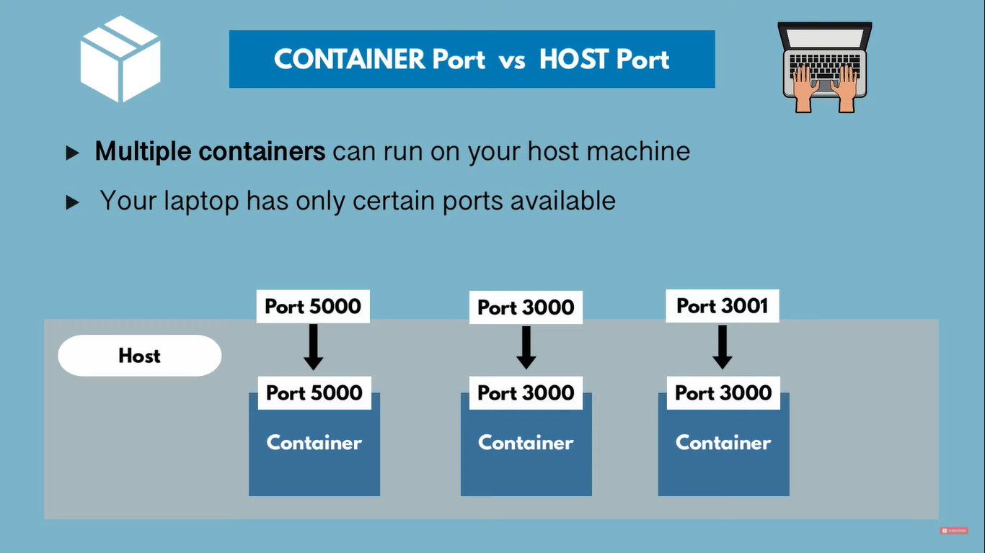

**DOCKER WORFLOWS:**

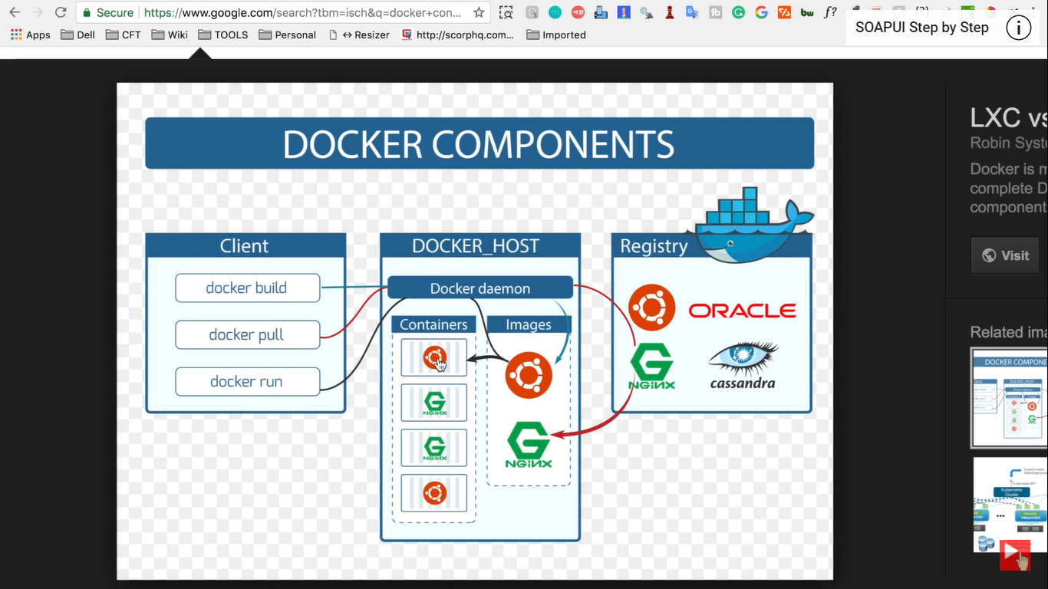

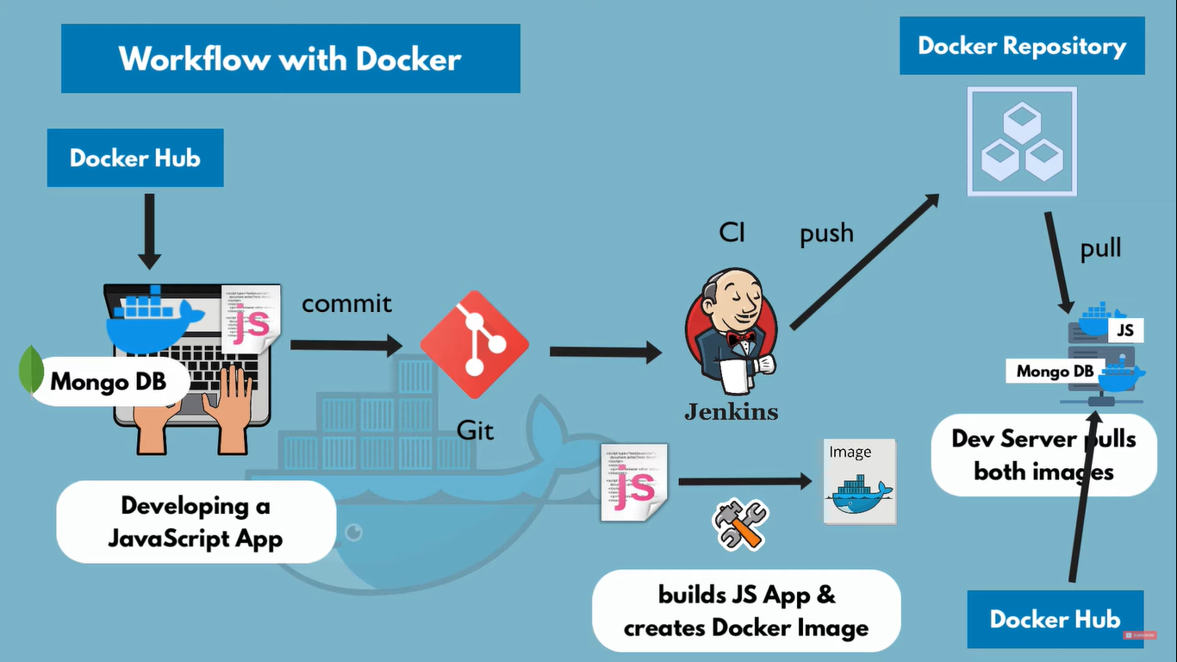

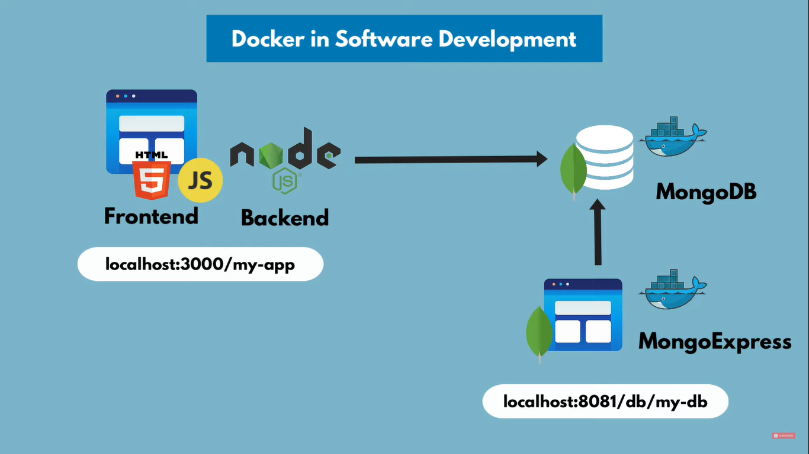

**DOCKER NETWORK:**

* Docker containers on same network can connect with each other
* Image before (Docker image packaging)

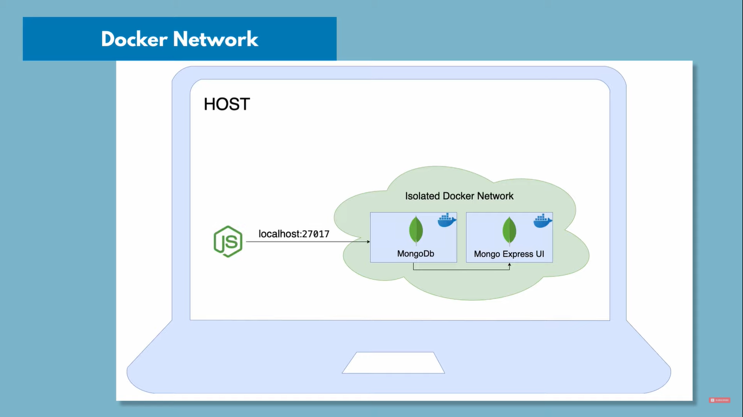

* Image after (Docker image packaging)

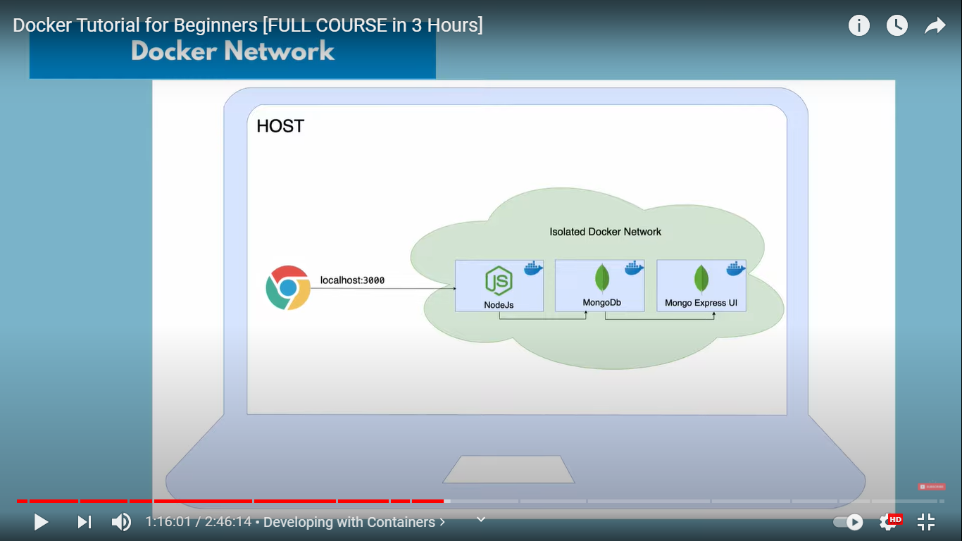

**WHAT IS DOCKER-COMPOSE:**

* Creates its own network
* Easy syntax and effective
* Used to connect multiple containers
* yaml file
* docker-compose.yml
* it will be used on the server to deploy all the applications/services

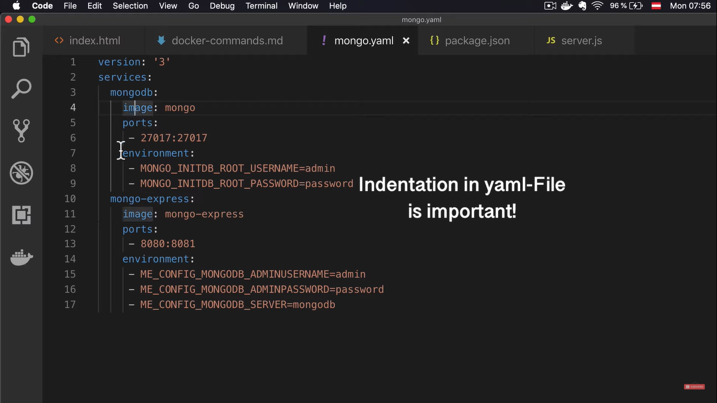

* **docker-compose -v à** show the version
* **docker-compose config à** shows the content of the file
* **docker-compose up à** to start the docker-compose
* **docker-compose down à** to stop the docker-compose
* **docker-compose up -d --scale database=4 à** used to scale the services

**WHAT IS Dockerfile:**

* It must be named Dockerfile
* Dockerfile has no extensions

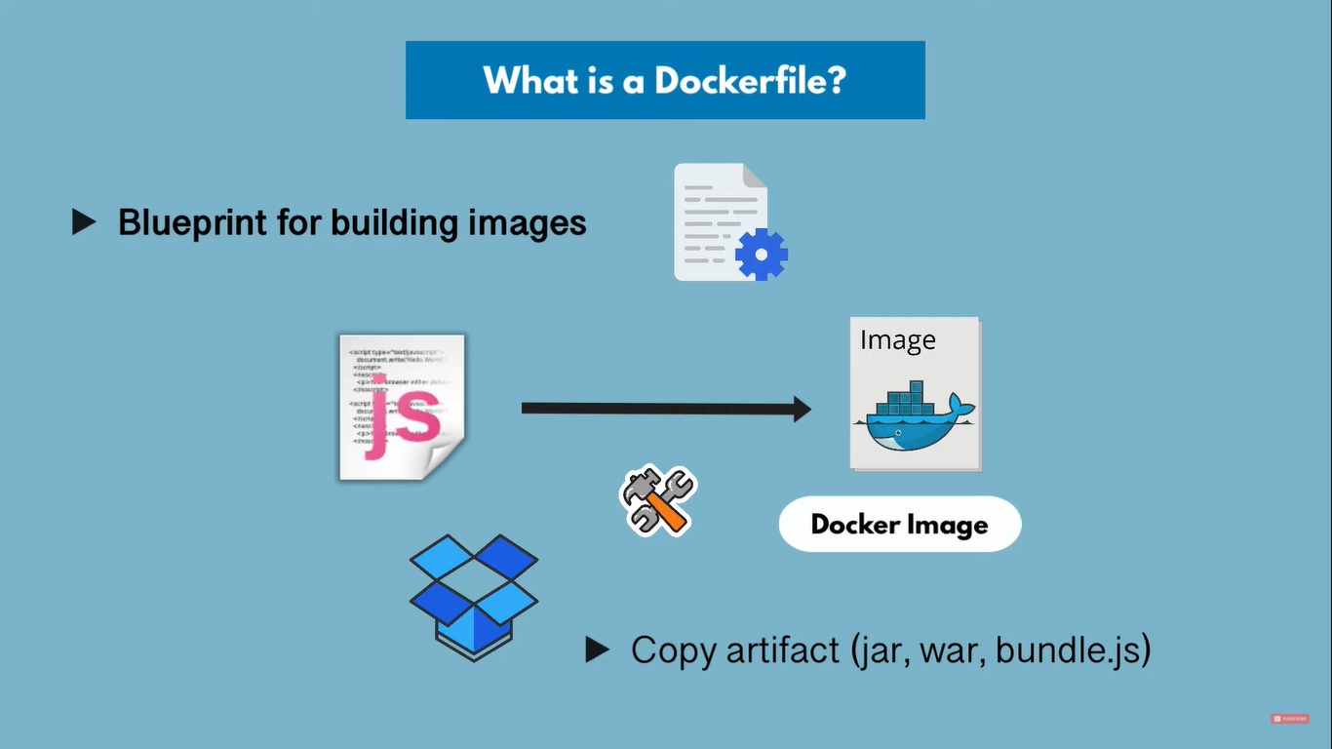

* Run commands runs inside a container(runs during building of image)
* Copy on the host
* Cmd is the entry point (execute when you create container out of image)
* There can be many run command but only one cmd command

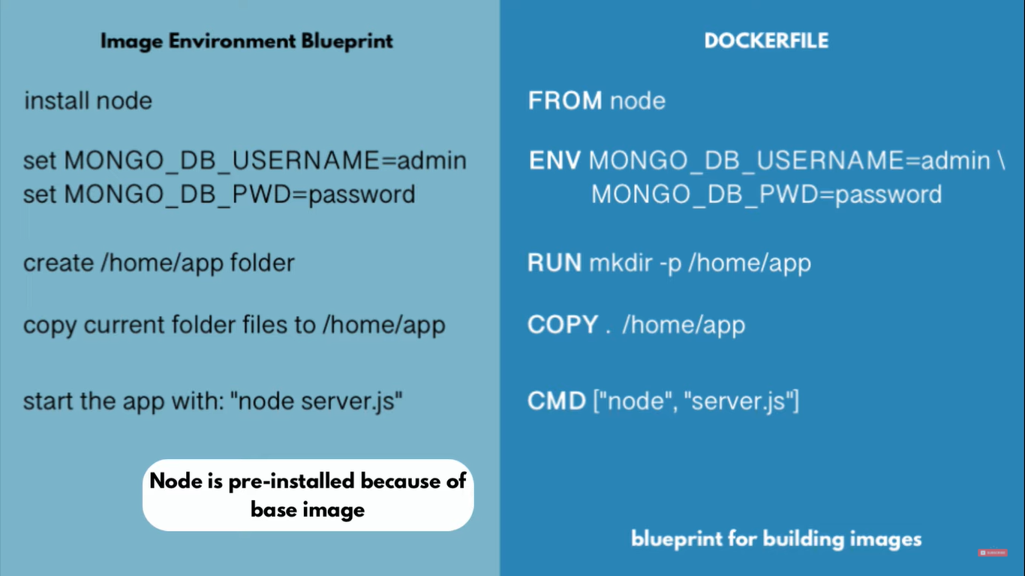

* Base image alpine:3.10 is lightweight
* Every image is built using some other image

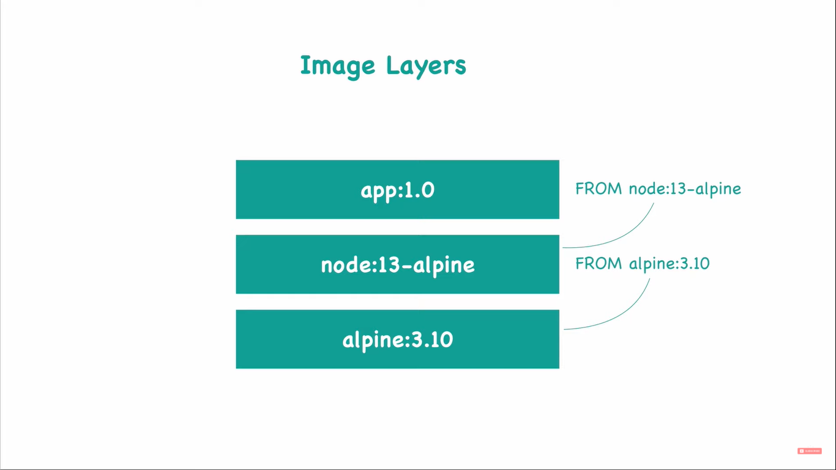

**DOCKER BUILD:**

docker build -t <app-name>:<version|tag> <Dockerfile-directory-path>

docker images à to verify whether the image is created

**DOCKER RUN:**

docker run <image-id>

**DOCKER VOLUME:**

* Used for Data persistence
* Share data among different containers

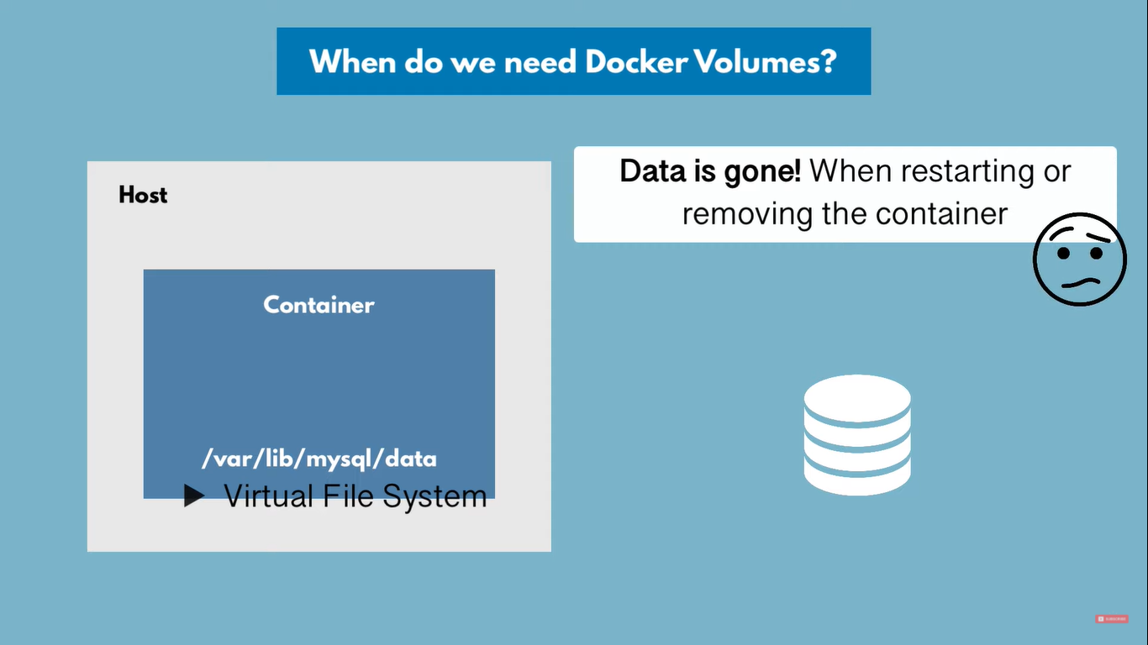

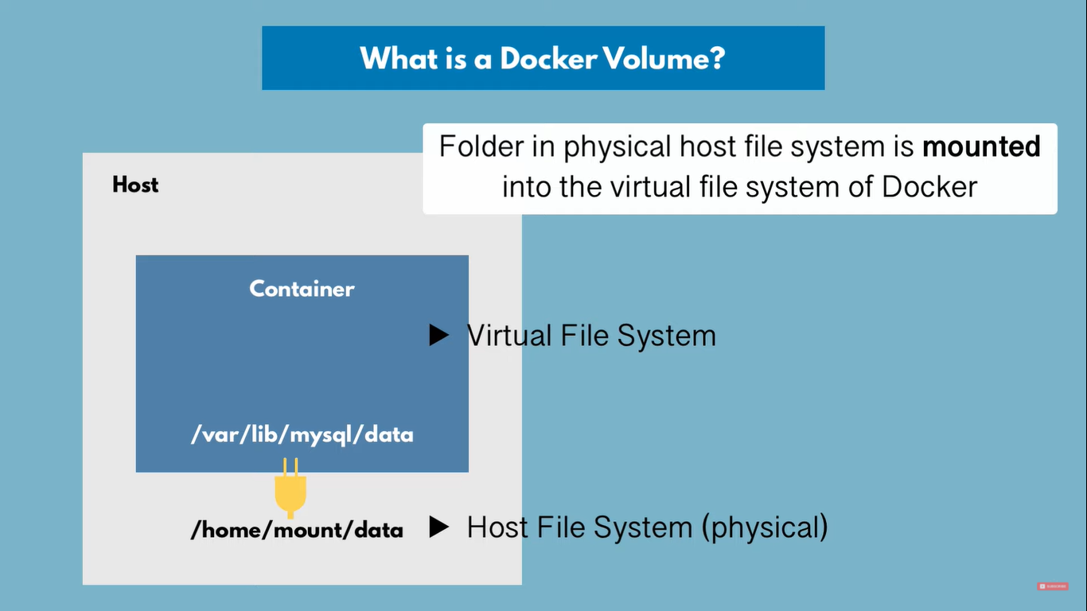

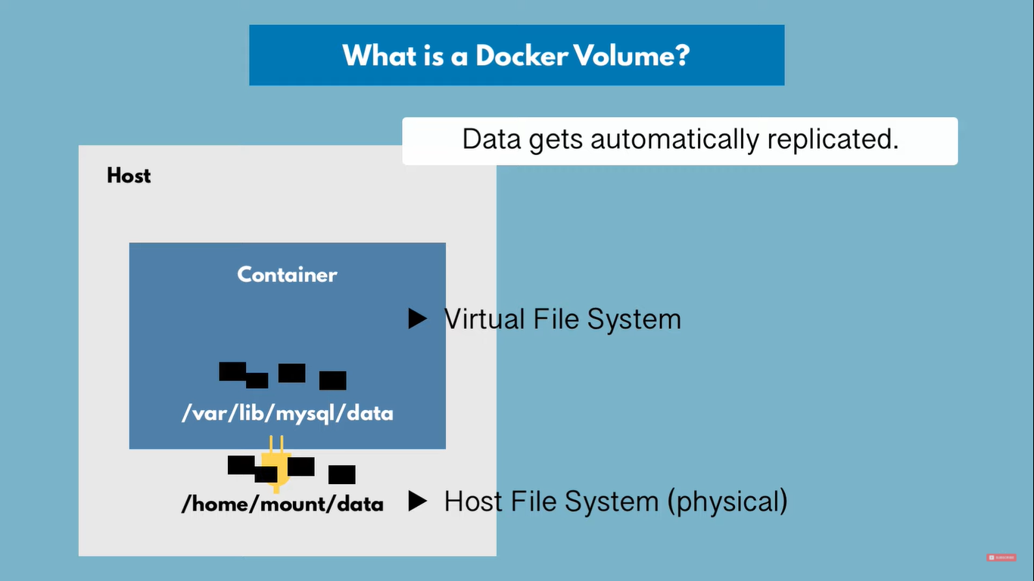

**TYPES OF DOCKER VOLUME:**

* We can specify the location in host machine to store the data

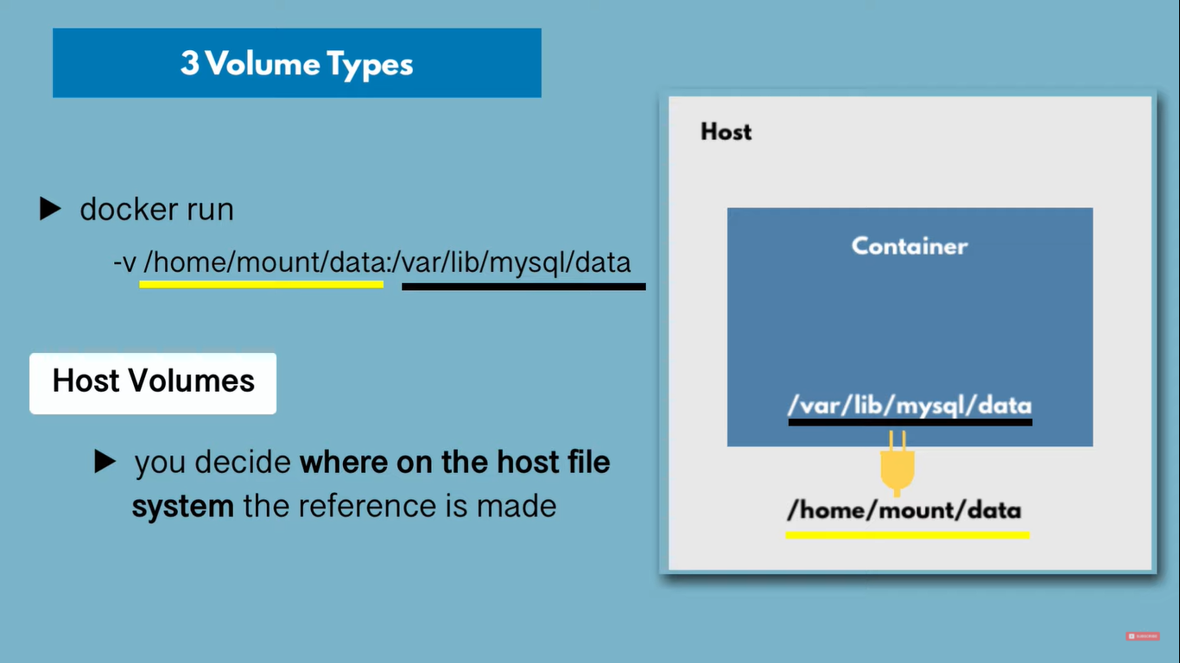

* We cannot specify the location in host machine to store the data (anonymous volumes)
* It creates a folder automatically and stores all data

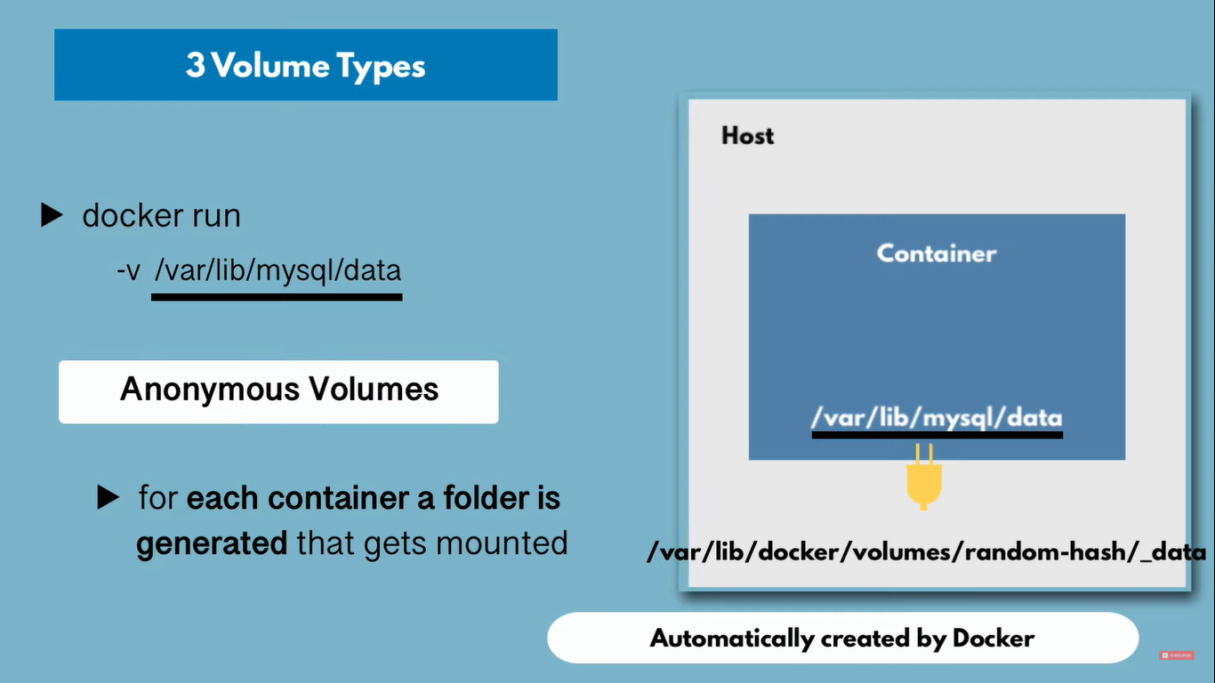

* Improvement of anonymous volumes
* Can reference a name
* Should be used in productions

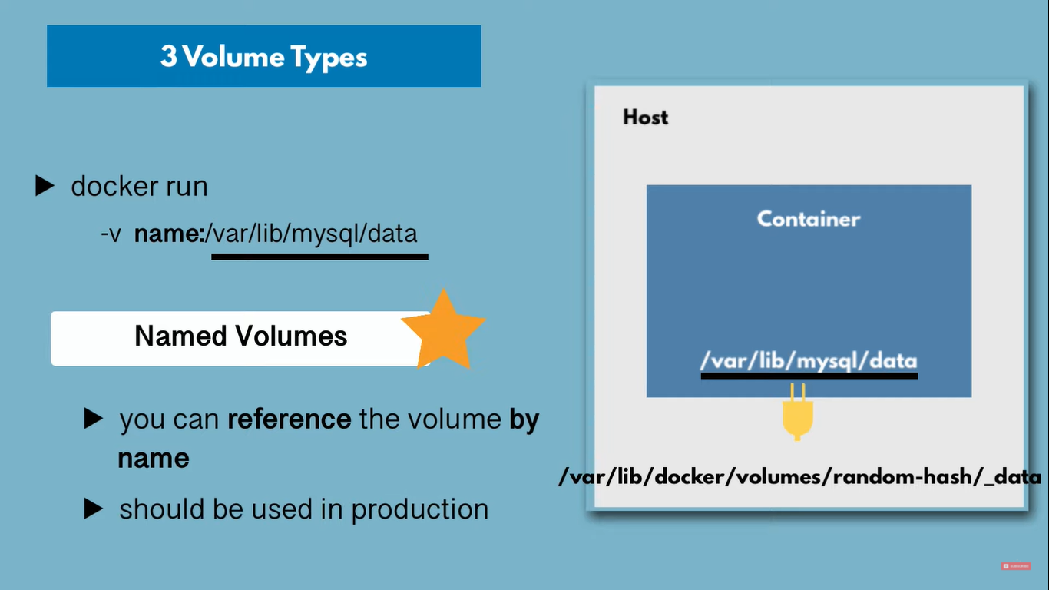

* Docker volumes in docker-compose

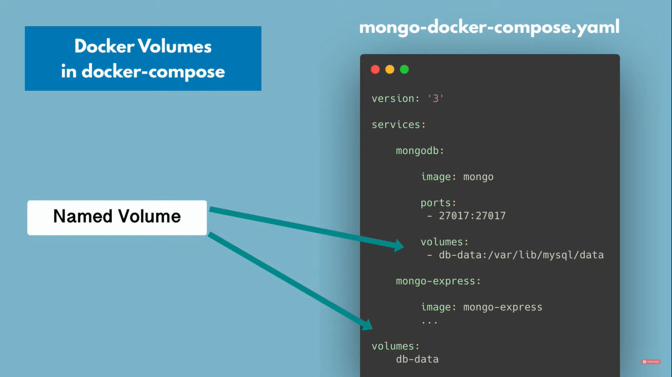

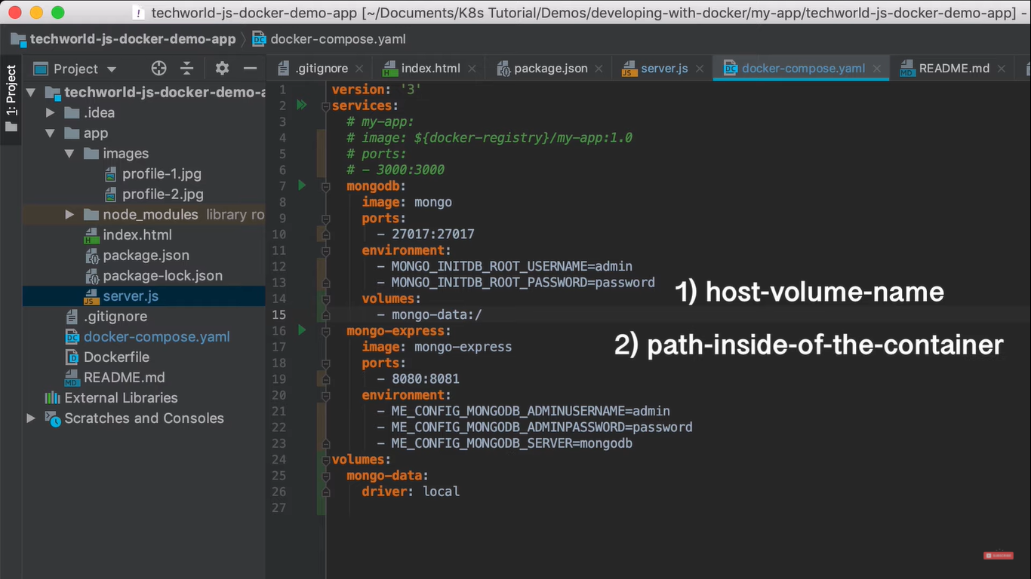

* Each database may have different paths

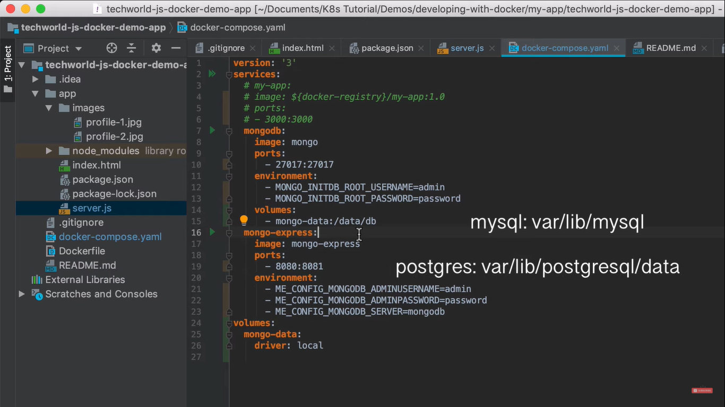

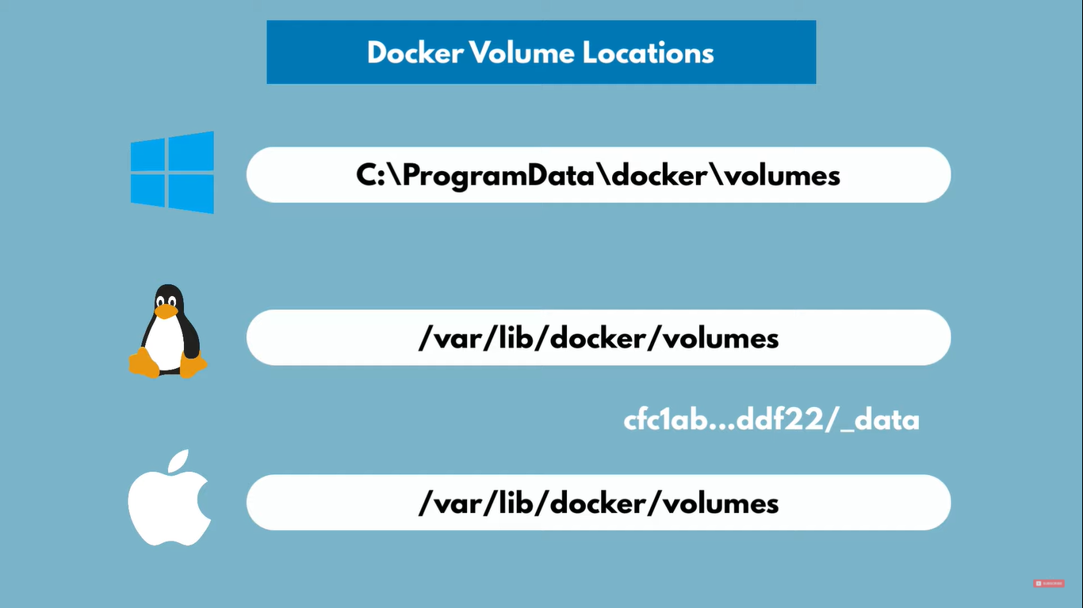

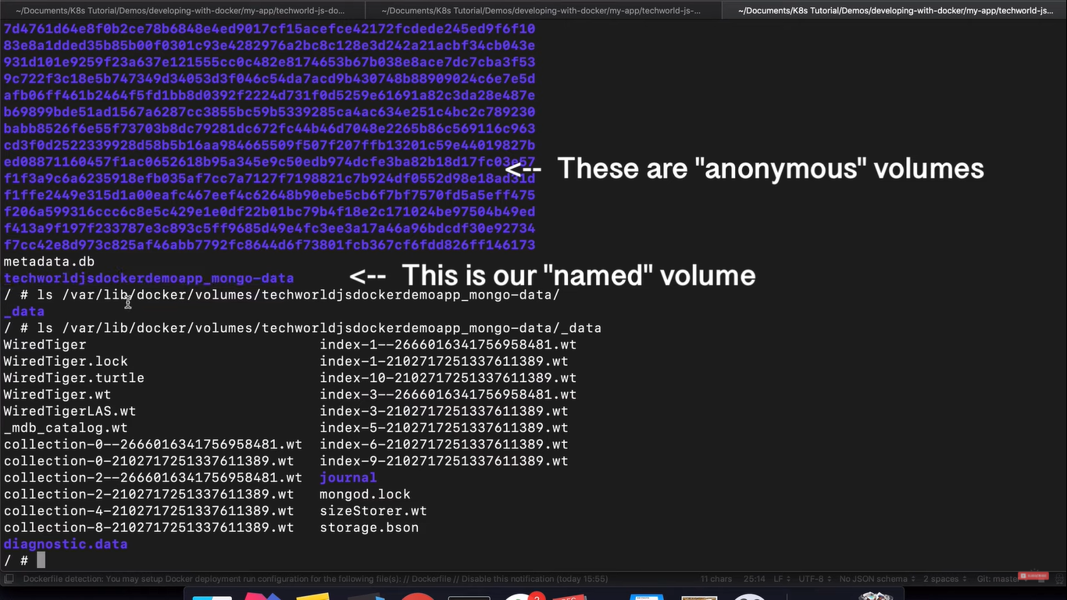

**DOCKER SWARM:**

* Tool for container Orchestration
* To control 100’s of containers
* Manager-worker model
* Group of machines running docker and are joined in a cluster

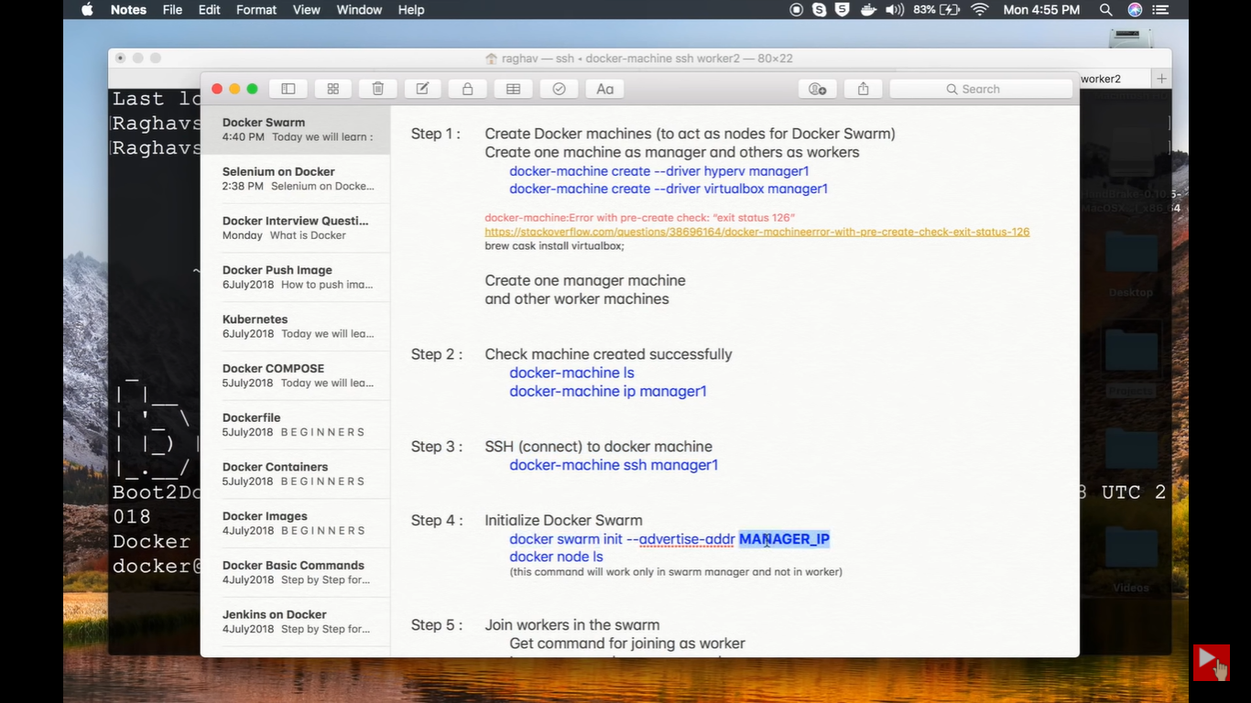

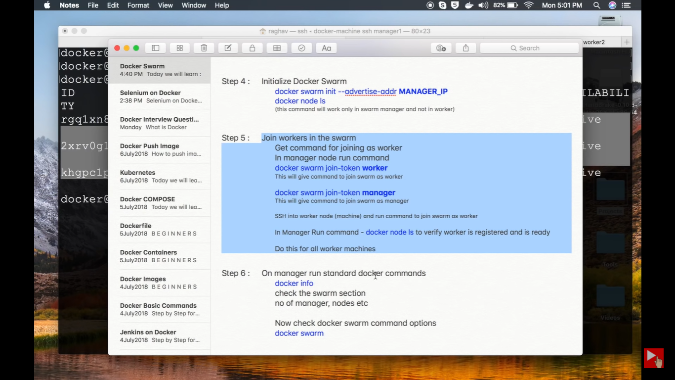

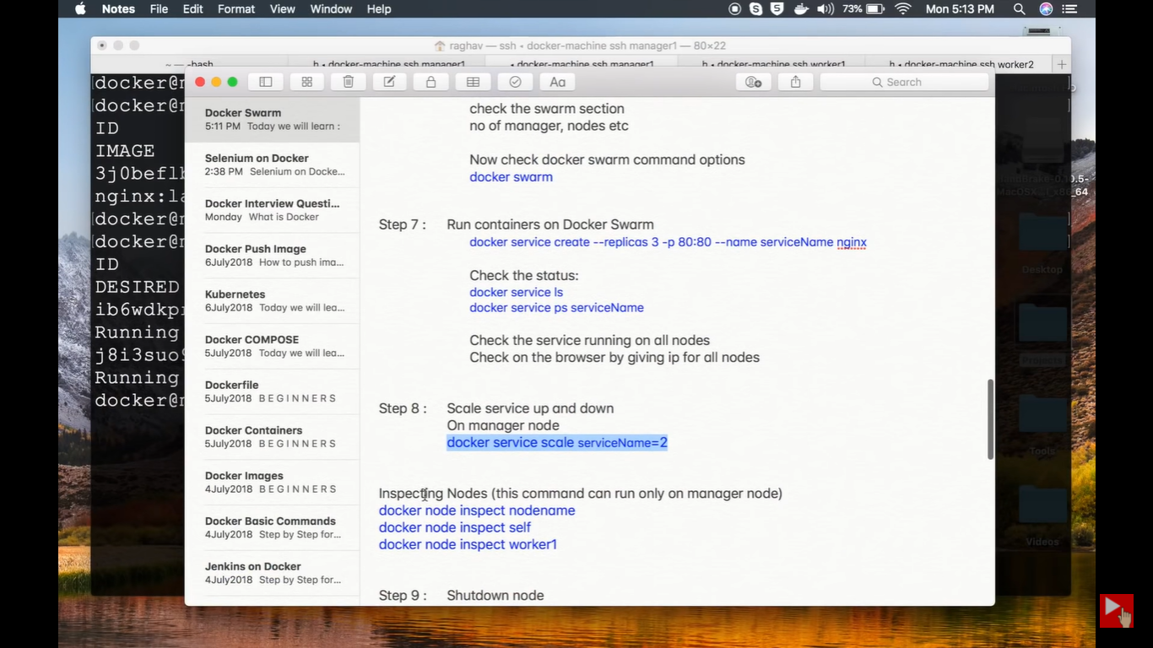

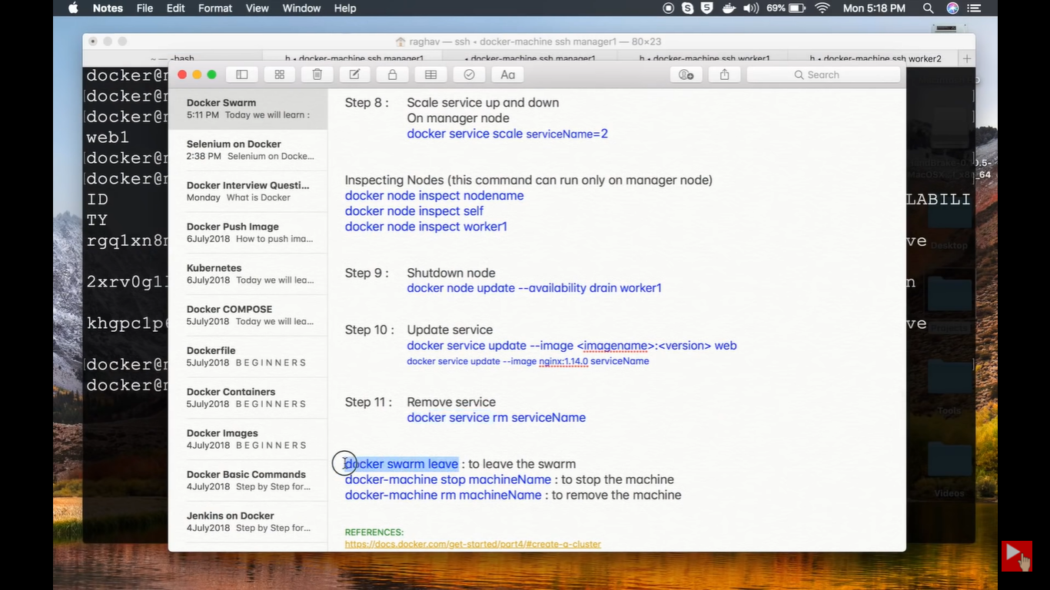

**DEPLOYED A STATIC WEBSITE USING DOCKER:**

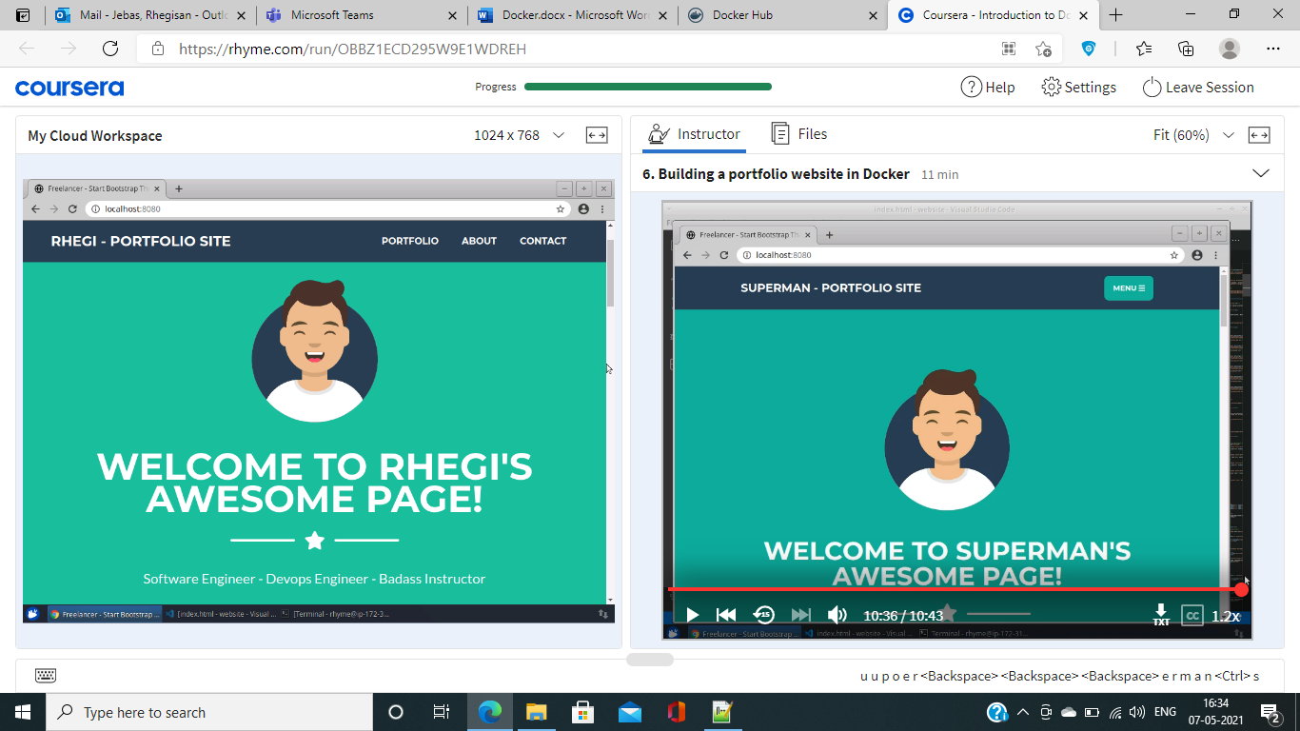

**CREATE IMAGE TAR FILE FROM DOCKER IMAGE:**

sudo docker save <image-name> > example.tar

sudo docker rmi -f <image-name>

sudo docker load example.tar

**CREATE IMAGE TAR FILE FROM CONTAINER AND EXTRACTING BACK TO IMAGE:**

sudo docker export <container-name> > example.tar

sudo docker import - <exampe-image-name> < example.tar

**GETTING STARTED WITH DOCKER:**

